View-

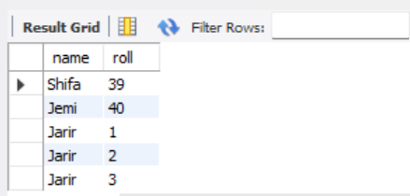

create view stu_info as select name,roll from STUDENT_DATA;

select * from stu_info;

trigger-

student data

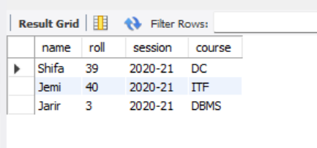

Table3-

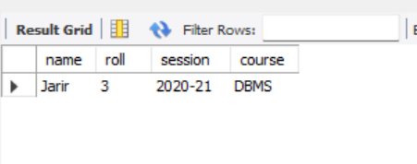

create trigger table5 after insert on STUDENT_DATA for each row insert into table3 values(new.name,new.roll,new.session,new.course);

INSERT INTO STUDENT_DATA(name,roll,session,course) VALUES('Jarir',03,'2020-21','DBMS');

select * From STUDENT_DATA;

select * from table3;